**DEPATRMENT OF COMMERCE**

**ABOUT THE DEPARTMENT**

The department of Commerce has been introduced  in the institution in the academic year 2017-18 with one course of B.Com (G) consisting of 17 students. This department was staffed by distinguished and knowledgeable faculty. In 2017-18, the B.Com. (Computer Applications) program was also created to meet the enormous demand from the student body. This department produced a large number of distinguished scholars with the necessary expertise. In terms of both staff size and student enrolment, the Department of Commerce is one of the largest departments at the college.

Faculty members act as mentors and advisors to students, offering career counselling, academic advice, and assistance with both professional and personal growth. They assist students in choosing classes, navigating their academic programs, pursuing research opportunities, and investigating career choices both inside and outside of the commerce industry. They contribute to the development of departmental policies, the evaluation of academic programs, and the formulation of decisions that affect the department's and the institution's general operation.

**VISION**

* “From the class room to spheres of the world and transformation of the student to a dedicated professional, a successful entrepreneur a dynamic business leader and a motivated researcher working towards the growth of the Nation.”

MISSION

* “ To make the students to perceive knowledge through academic co-curricular and extra curricular activities by incorporating leadership and entrepreneurial quality among students”.

**PROGRAMS OFFERED**

B.Com (Computer Applications)

**FACULTY:**

|  |  |  |  |  |
| --- | --- | --- | --- | --- |
| **S.No.** | **Name of the Faculty** | **Designation** | **Qualification** | **Period of Service** |
| 1 | A.NAGARANI | LECTURER | M.Com(Information systems),UGC-NET, TS-SET,Accounting Technician | 2024- Till date |
| 2 | P.RAJITHA | LECTURER | M.COM,TS- SET | 2021- Till date |
| 3 | MD.AZRA SHAREEN | LECTURER | M.Com, B.Ed | 2021- Till date |
| 5 | R.SHYAMALA | LECTURER | M.Com | 2024- Till date |
| 6 | M.VANAJA | LECTURER | M.CoM, MBA,TS-SET,(Ph.D) | 2019-2024 |
| 7 | T.DHANALAXMI | PRINCIPAL(FAC) | M.CoM, NET | 2019-2022 |
| 8 | R. RAJITHA | LECTURER | M.Com, B.Ed, TS-SET | 2017-2023 |
| 9 | G.GAYATHRI | LECTURER | M.Com | 2018-2020 |
| 10 | N.SAMPATH | PRINCIPAL(FAC) | M.Com, Ph.D | 2017-2020 |

**CONTACT US:**

Mail:ttwrdccommerce23@gmail.com

.

**DEPARTMENT OF COMMERCE RESULT ANALYSIS**

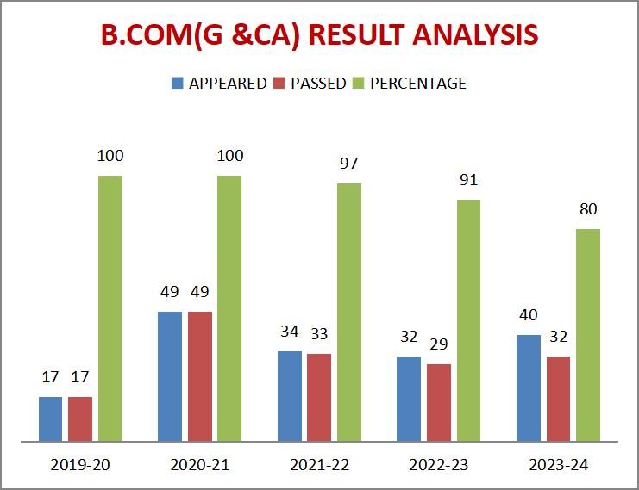

**DEPARTMENT OF COMMERCE ACTIVITIES**

**ACTIVITES:**

**FIELD TRIP**

**FIELD TRIP 2018-19**

* **No. of students involved: 20**
* **Names of the teachers involved:       R. Rajitha,  Faculty in Commerce**

**G. Gayathri, Faculty in Commerce**

* **Date of visit: 18-07-2019**
* **Place of visit: Agriculture form, kairgam,Asifabad**

                                    Telangana Tribal Welfare Residential Degree College (G), Buruguda , Asifabad  organized field trip to Active Farm located Kairgam village,Asifabad mandal of Kumuram Bheem  on 18 th July 2019. 15  registered students from B.Com second  year students  accompanied by the faculty members R. Rajitha, G. Gayahri.

* Objectives:

                       The Objective of the form  is to make the non-farmers engage with nature, agriculture, develop respect to farmer, value for food and love for mother earth.

* Learning’s/Findings:

                             7 Active Farm l is a service to educate in hands-on method in Agriculture, Farm Technology, Food Processing and Rural Exhibits primarily to non-farmers. They can know and learn about 25 plus crops namely cereal, millets, oil crops, pulses, commercial crops, medicinal plants, vegetables, fruits, creepers and others; Food processing units like Small Paddy mill, oil mill, bread making unit, milk chilling unit, Bio gas unit and handloom unit and Domestic Animals like Cow, Buffalo, Ducks, Birds, Hens, Goose, Sheep and Goats.  The trip gave an insight on how much effort goes into one plate of food, practical knowledge on agriculture and at the same time being more responsible towards protection of environment. It has indeed provided a platform to learn, experience and live the life of a farmer for a day.

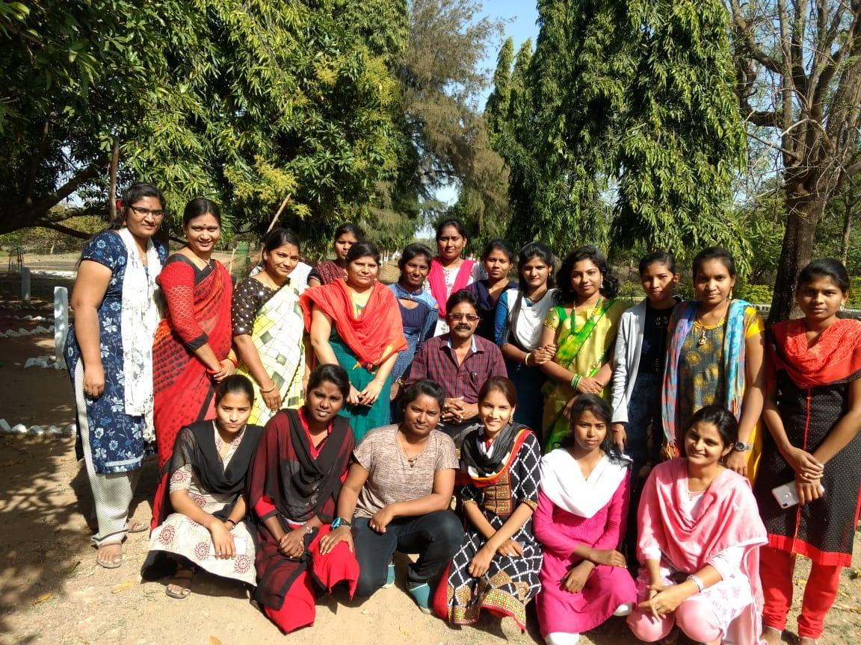  
**FIELD VISIT : Agriculture form, kairgam,Asifabad**

**FIELD TRIP 2021-22**

* **No. of students involved: 45**
* **Names of the teachers involved:       M. Vanaja, DL in Commerce**

**R. Rajitha,  Faculty in Commerce**

**P. Rajitha, Faculty in Commerce**

**Azra shareen, Faculty in Commerce**

* **Date of visit: 02-12-2021**
* **Place of visit: Heena Industries**

     Department of Commerce organized a Field trip and Visited Heena Industries  along with B.Com III Year students.25students visited the industry.

* Objectives:

     To provide  exposure to commerce based industries and equip them with skills by hands on experience.

* Learning’s/Findings:

Students observed the moulds used for making thread bundles and authorities’ demonstrated method of preparation of thread  to students.

Raw materials used for thread making is mainly cotton and various machines used for separation of seeds and making thread bundles from cotton.

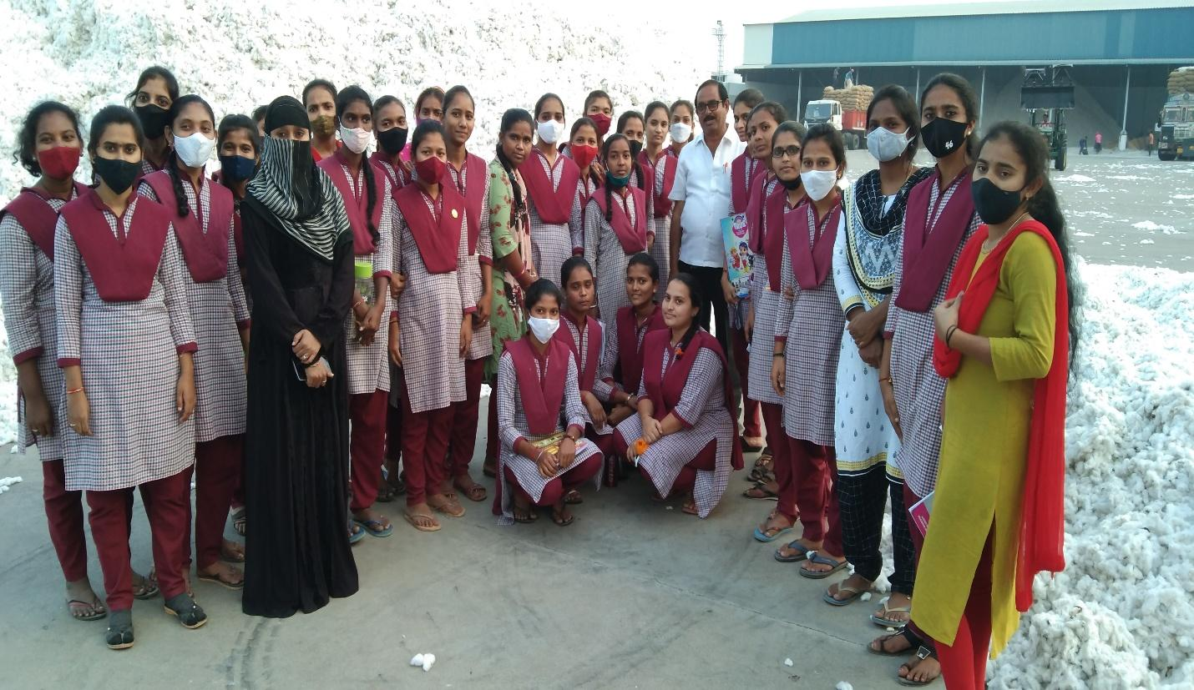 **FIELD VISIT: HEENA COTTON INDUSTRIES, ASIFABAD**

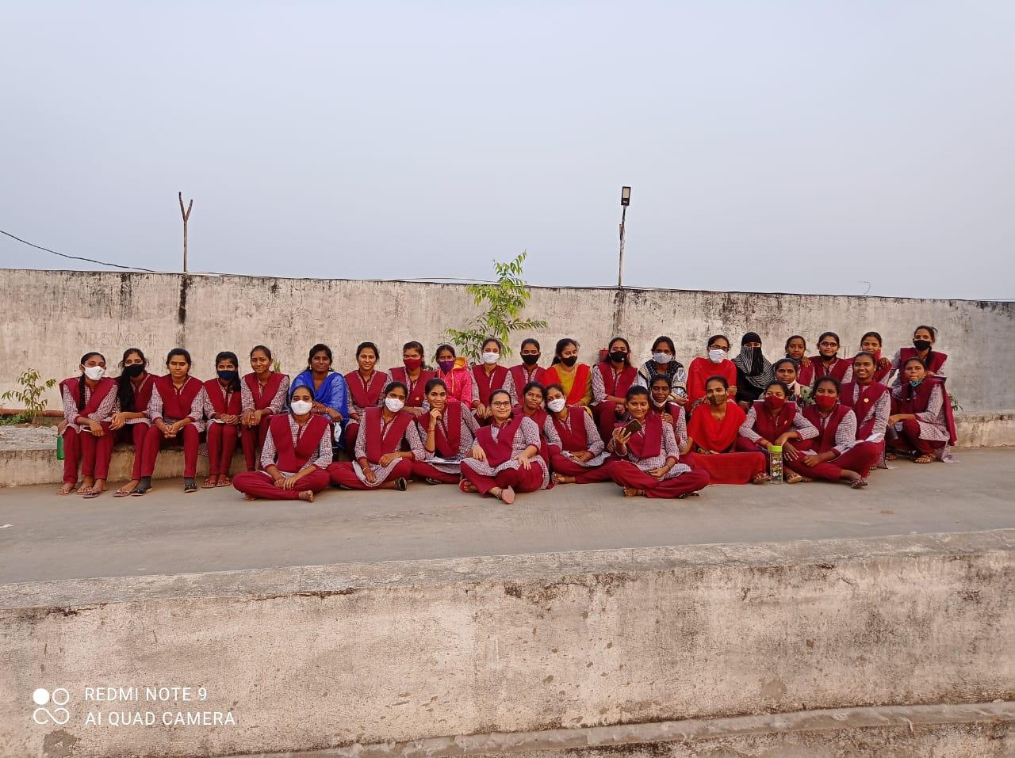  
**FIELD VISIT: HEENA COTTON INDUSTRIES, ASIFABAD**

**FIELD TRIP 2022-23**

* **No. of students involved: 28**
* **Names of the teachers involved:  M. Vanaja, DL in Commerce**

**R. Rajitha,  Faculty in Commerce**

**P. Rajitha, Faculty in Commerce**

**Azra shareen, Faculty in Commerce**

* **Date of visit:**
* **Place of visit: Gangapoor**

                Department of Commerce organized a Field trip and Visited Gangapoor along with B.Com students.28 students visited that place.

* Objectives:
* Historic monuments of temple.
* Revenue generation structures of temple at jathara time.
* Facilities provided by the government at the time of jathara .
* Cultural heritage of the place.

Outcome of the visit: Students got knowledge about history and culture of  that particular area.

* Feedback:  Feedback is collected.

Resouse  person:  M. Vanaja (**DL in Commerce)**

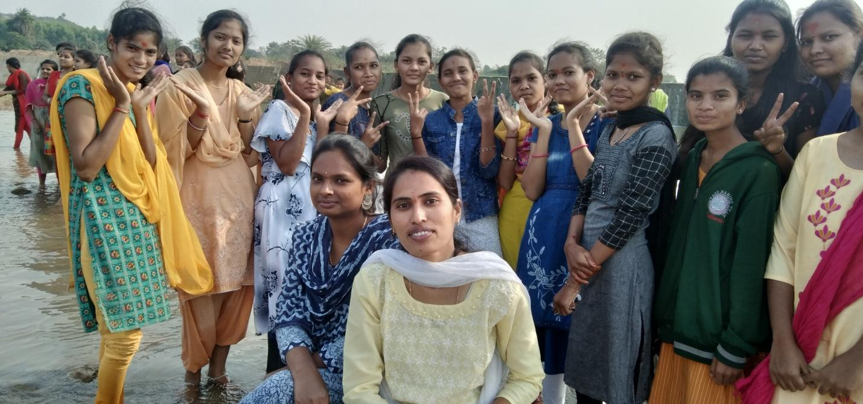

**FIELD VISIT: GANGAPUR, ASIFABAD**

**FIELD TRIP 2023-24**

* **No. of students involved: 15**
* **Names of the teachers involved:  M. Vanaja, DL in Commerce**

**P. Rajitha, Faculty in Commerce                                                                                                                                                                                                                                                          Md.  Azra shareen, Faculty in Commerce**

**R. Shyamala, Faculty in Commerce**

* **Date of visit:**
* **Place of visit: State Bank of India**

           Department of Commerce organized a Field trip and Visited State bank of India  B.Com II Year students.15 students visited the State bank of India.

* Objectives:
* To determine reasons behind opting for a fixed deposit.
* To know the most preferred fixed deposit policy.
* To determine customers' perception towards corporations towards corporation bank and their expectations from private bank.
* To determine the feedback on services provided by a corporation bank to study the types of benefits provided by the services.
* Learning’s/Findings:

The students learn how to open their own accounts. They observed in  the main office, there were four counters-cash counter, passbook counter, enquiry counters and deposit counter and  monetary transactions in the bank with customers.

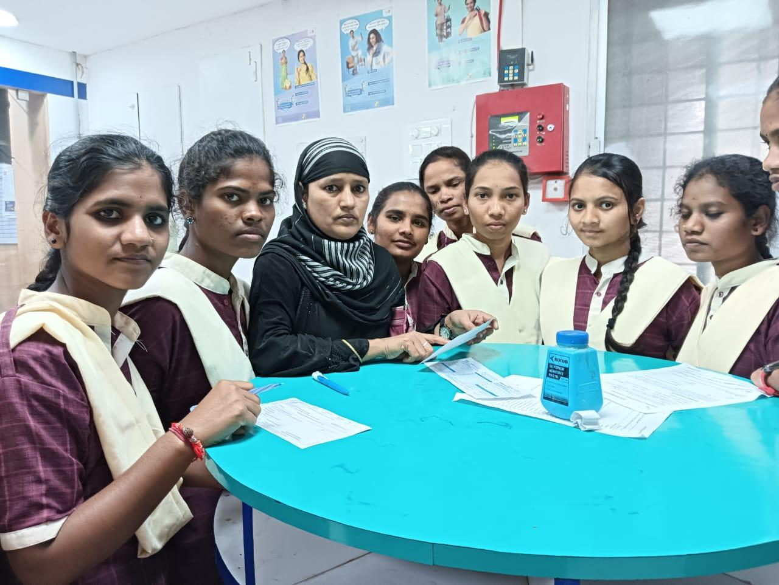

**FIELD VISIT- SBI BANK**

**FIELD TRIP 2023-24**

* **Place of visit: SBI ATM**

           Department of Commerce organized a Field trip and Visited State bank of India ATM at Asifabad along with  B.Com students. 20 students visited the State bank of India.

* Objectives:
* Working of the ATM machine.
* Swipe of the ATM card.
* Where the money is stored and how the ATM machines are refilled.

* Learning’s/Findings:

The students learn about the working of the ATM machine . they learn how to swipe the card and enter the PIN and also became aware  of how important it is to safeguard the PIN.

Feedback: feedback is collected

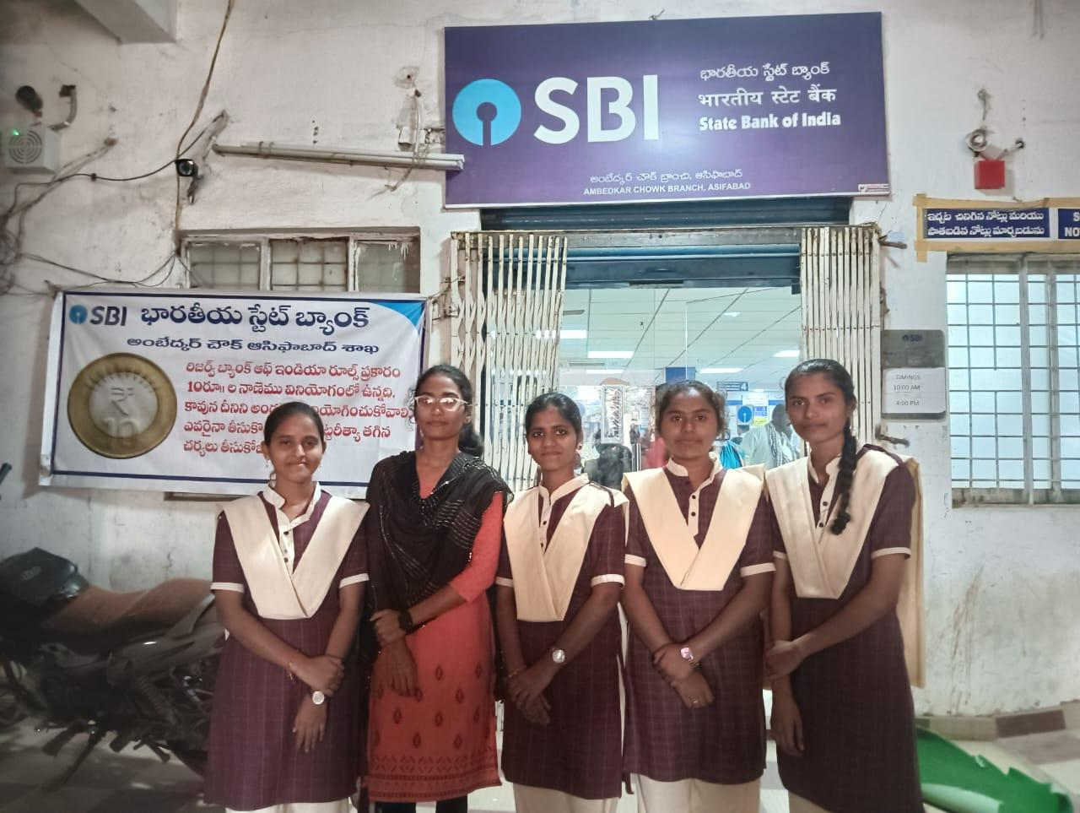

**FIELD VISIT- SBI ATM**

**DEPARTMENT OF COMMERCE**

**EXTENSION ACTIVITIES REPORT**

**2018-19**

**Consumer Store Extension Activity Report**

The department of Commerce students of Telangana Tribal Welfare Residential Degree College (G), Asifabad organized a consumer store at Ekalavya Residential School –Hyderabad, on the occasion of first National Sports meet in January-2019.

**Objectives:**

#### Identifying Consumer Demands

#### Convenience of timing

#### The goals of retail sales

**Goals:**

 (i) To serve a link between the manufacturer and end consumers.

(ii) To improve communication with students.

(iii) To improve sales target

(iv) To provide efficient customer service knowing the power of mouth advertisement

 (v) To build image among students.

(vi) To improve social responsibility

(vii) To serve different markets

(viii) To get quick feedback about the merchandise sold and consumer services offered

 (ix) To convert visitors to buyers

(x) Optimum utilization of fixed cost related expenses.

**Outcome of extension activity:**

1. The students to know needy and other support extended to the students.
2. Students were thankful to the College,  and the Department for giving them a chance to know the business ideas.
3. Apart from studies the students got a chance to run the consumer store at college level.

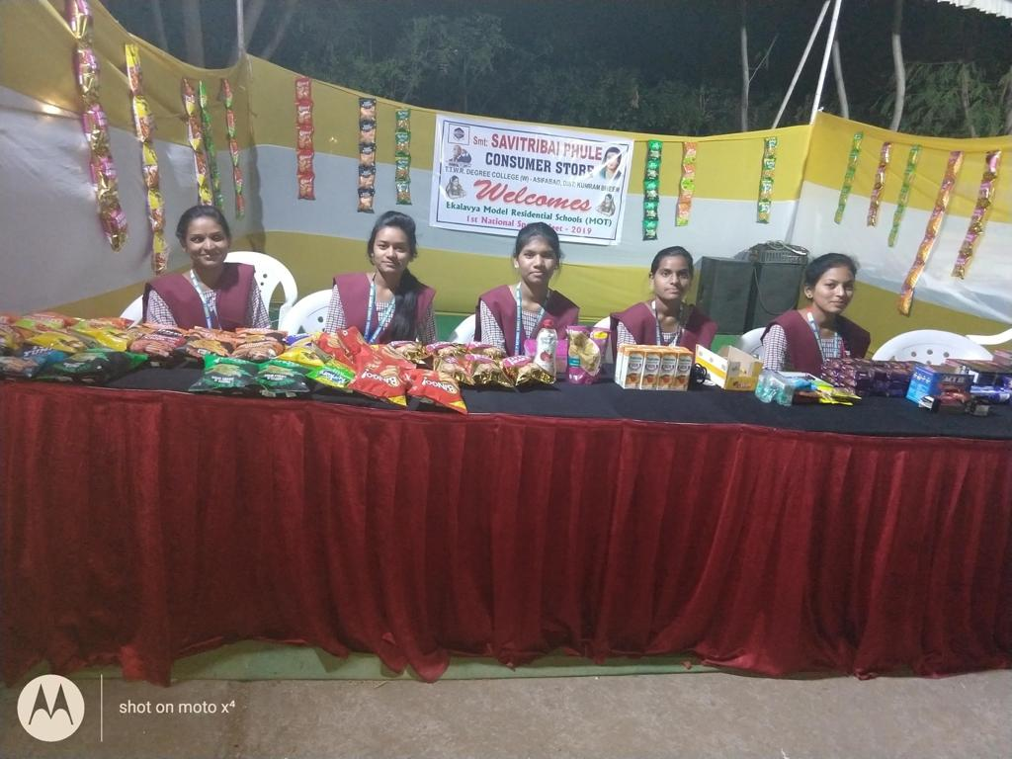

**CONSUMER STORE AT EMRS, HYDERABAD**

**2019-20**

**Road Safety Awareness Programme**

**Report on Road Safety Awareness Programme**

                                  Road Safety Awareness Programme Conducted on 12-02-2020 at Asifabad,  kumuram bheem Distirct. This programme was Organised  by Telangana Tribal Welfare Residential Degree College (Girls), Buruguda, Asifabad. In this programme   National Service Scheme (NSS)  Volunteers and other students participated in “Road Safety Awareness program” on the occasion of “National Road Safety Awareness Month 2021” (From 18th January to 17th February)” which is on 12-02-2020. Every Year Central Government plans a programme of National Road Safety Awareness month but from this year with the aim of reducing the Road accidents and decrease victims by 50% by the end of 2025, State Government planned to conduct the same program for a month.

**Objectives:**

* To encourage all the travelers to follow the traffic rules and wear helmets and seat belts while driving.
* To implement the new preventative measures which are proved to lessen the risk of road accidents, death or injury.
* To be aware the people about the speed limit of vehicles to prevent road accidents.

                              As a part of this Principal of TTWRDC(G), Buruguda ,Asifabad  Neelam Sampath garu  creating awareness in people by going to various institutions, organizations and other places. He  spoke few words about how Traffic has increased and how few people are irresponsible not following rules and guidelines. First officer name – explained all the rules and regulations to be followed while driving. Also told about the fines that are introduced for the safety of people by state Government. He  told the stats of road accidents and deaths that are occurring in India per year and few steps to reduce them and said that you as students should come forward with new projects to decrease Traffic problems and accidents. He has spoken about how to drive, precautions, rules and regulations etc so we can be safe on road. He told everything with suitable examples.   Also explained about various symbols Mandatory symbols, Cautionary symbols and Informatory symbols. Finally all the people gathered taken a pledge that we all will follow the rules and make others to follow and be safe. Along with them Unit Program officers, Volunteers of all units and other students attended.

Photo Gallery:

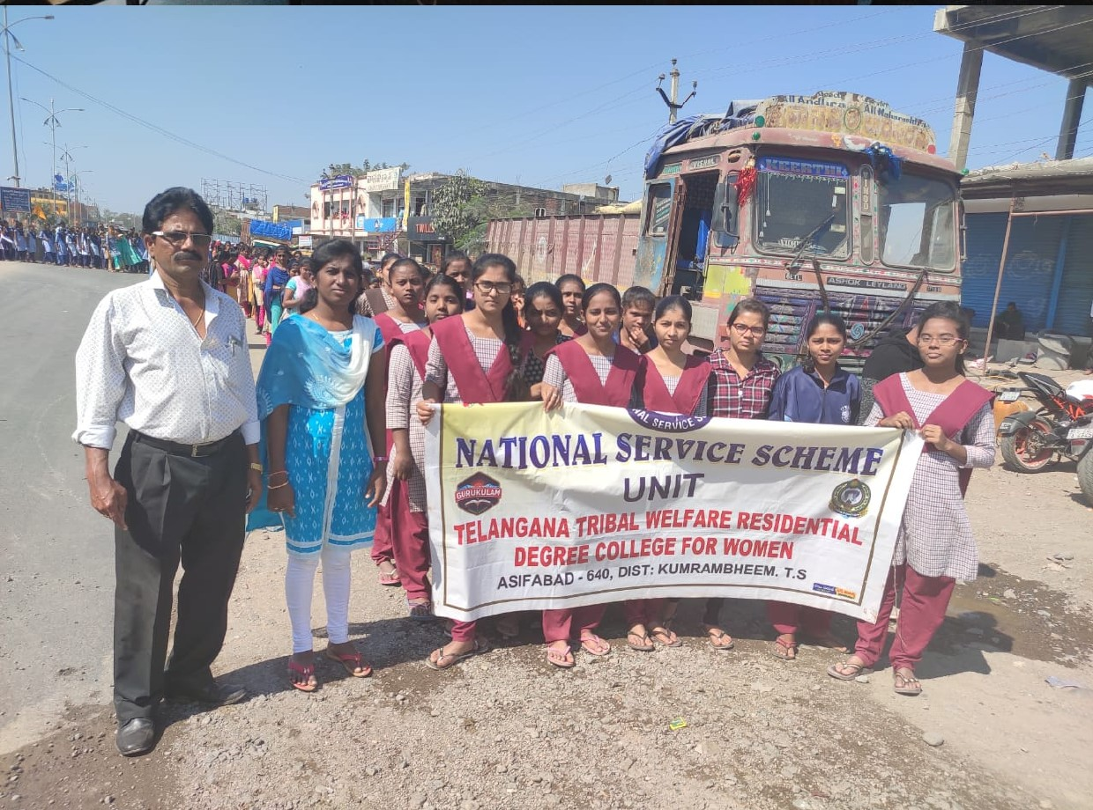

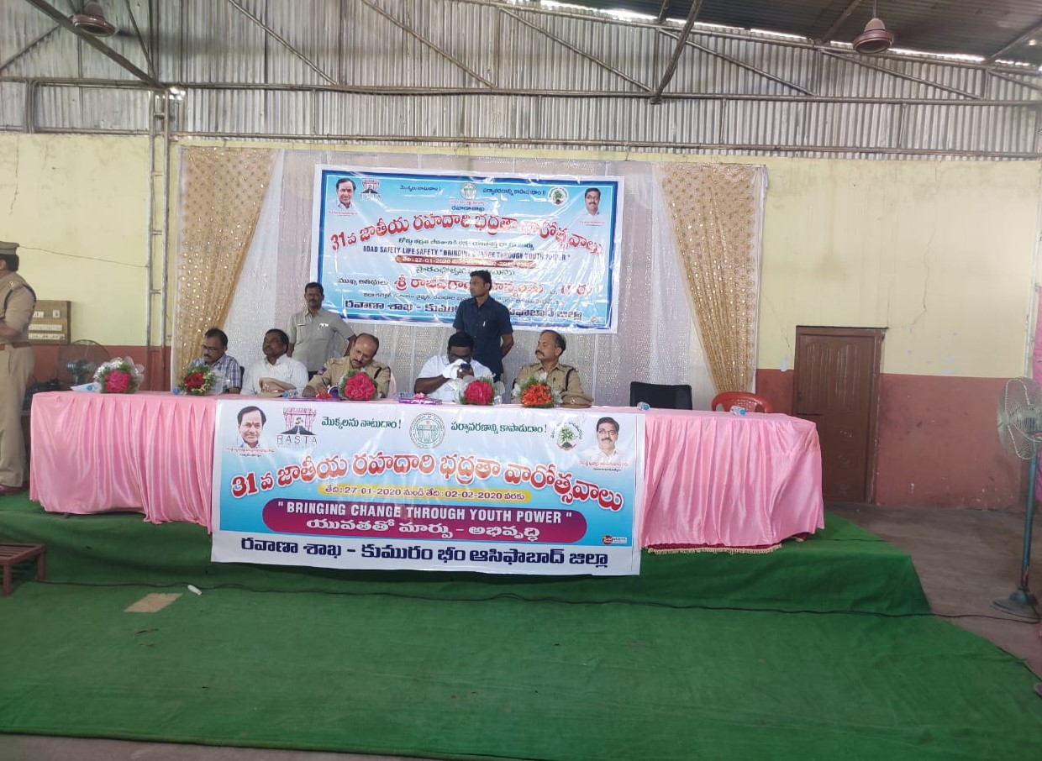

**ROAD SAFETY PROGRAMME**

**2022-23**

**Short –Term course on “Computerized Accounting”**

**Report on A short term course on “Computerized Accounting Tally ERP.9”**

                       Telangana Tribal Welfare Residential Degree College (Girls), Buruguda Asifabad undertaken by the faculty of Commerce, Commerce Department organizes  extension activity on importance of TallyERP.9  to the Commerce students for their  better future in the academic year 2022-23. A short term course on “Computerized Accounting Tally ERP.9” was started for the commerce students in the second week of February, 2023.

                       Tally is a well-liked accounting programme that companies use to control cash flow, inventory, and payroll. These are Tally's main goals: 1. Accurate financial record-keeping: Providing businesses with accurate financial record-keeping is Tally's main goal.

**Objectives:**

              This course is designed to impart knowledge regarding concepts of Financial Accounting Tally is an accounting package which is used for learning to maintain accounts. As this course is useful for Commerce students to get placements in different offices as well as companies in Accounts departments.

**Outcome of extention activity:**

                  The course will make the students proficient in creating and maintaining master vouchers, Day Book and P/L Accounts, payrolls, GST, E-Way Bills, Return filing etc. with the help of Tally Software. The course benefitted the students in pursuing career in accounting after completion of their studies.

**Photo Gallery:**

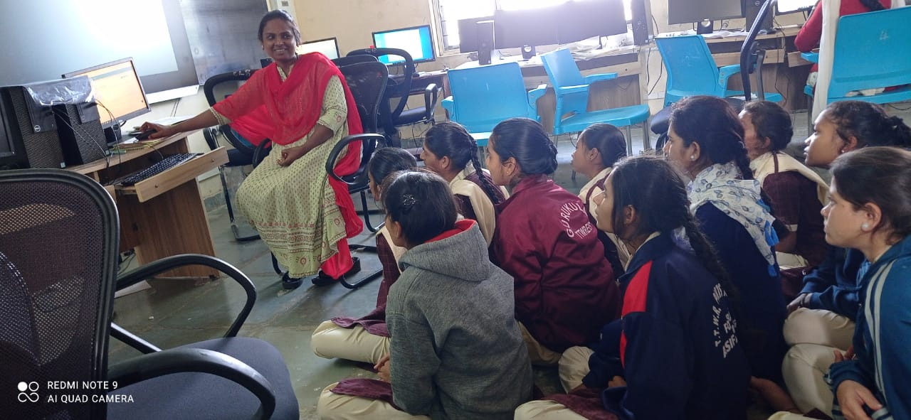

**TALLY PROGRAMME**

**DEPARTMENT OF COMMERCEGUEST LECTURES/ EXTENTION LECTURES**

                  A guest lecture on “ Computer Basics” was organized by the Department of Commerce, Telangana Tribal Welfare Residential Degree College (Girls), Asifabad, District Kumuram Bheem, Telangana.

|  |  |  |  |
| --- | --- | --- | --- |
| Date | Name of the Guest Lecture | Designation | No. of Students attended |
| 21-10-2019 | O. Arun Kumar | Lecturer in Computer Scince | 25 |

**Topic: Computer Basics**

**Objectives of the Programme:**

* Identify basic parts of a computer (Mouse, Keyboard, Monitor, USB Port)
* Explain how computers work.
* Explain the difference between computer hardware and computer software.

          He has delivered a lecture on preparation of Cost Sheet in the Manufacturing / Production Industries.

**Highlighting points**

* Identify basic parts of a computer (Mouse, Keyboard, Monitor, USB Port)
* Differentiate between software and hardware. Be able to turn a computer on and shut it down.
* Describe why computers are important.
* Explain how computers work.
* Explain the difference between computer hardware and computer software.
* Identify the operating system you have on your own computer and phone.
* Start up and shut down computers properly.

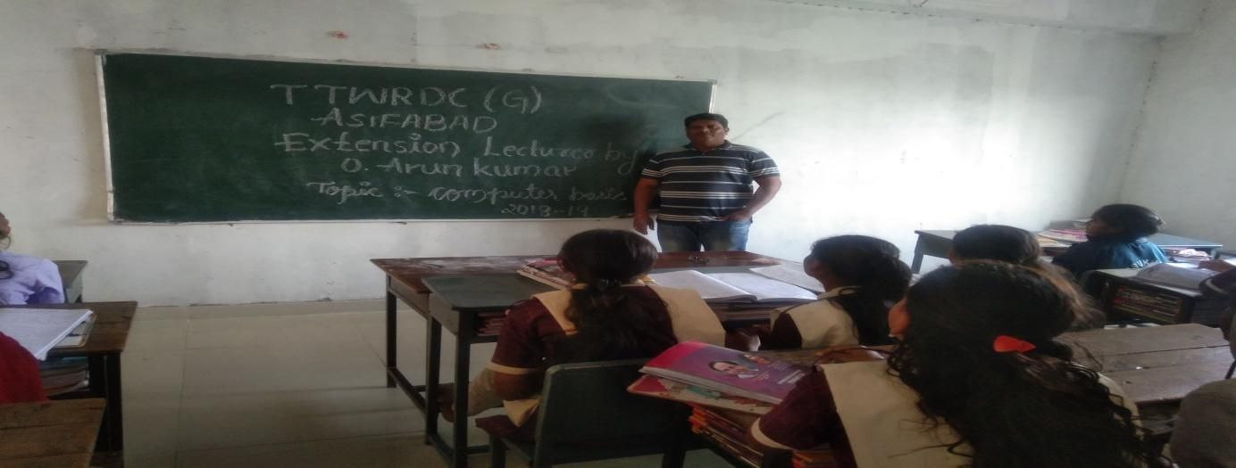**O. ARUN KUMAR, SRICHAITHANYA DEGREE COLLEGE, ASIFABAD**

**REPORT ON GUEST LECTURES ARRANGED 2019-20**

                 A guest lecture on “ Accounting Principles” was organized by the Department of Commerce, Telangana Tribal Welfare Residential Degree College (Girls), Asifabad, District Kumuram Bheem, Telangana.

|  |  |  |  |
| --- | --- | --- | --- |
| Date | Name of the Guest Lecture | Designation | No. of Students attended |
| 04-02-2020 | V. Ganesh | Lecturer in Commerce | 45 |

**Topic: Accounting Principles**

**Objectives of the Programme:**

* Maintenance of Records of Business Transactions
* Depiction of Financial Position of Business
* Calculation of Profit and Loss
* Providing Accounting Information to its Users

           He has delivered a lecture on preparation of Cost Sheet in the Manufacturing / Production Industries.

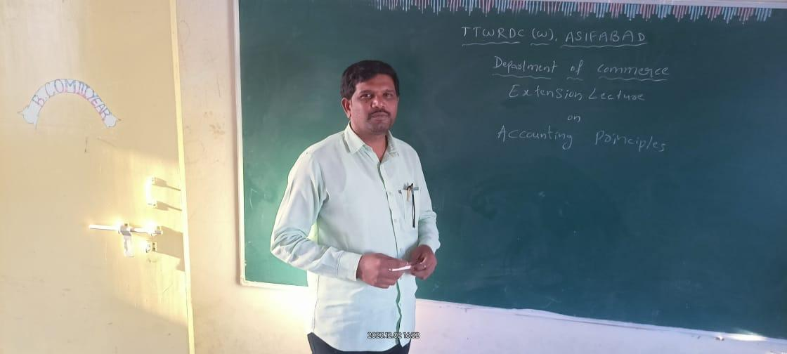

**V.GANESH, LECTURER IN COMMERCE, TTWRDC(W), UTNOOR**

**A REPORT ON GUEST LECTURES ARRANGED 2021-22**

                  A guest lecture on “ Preparation of Cost sheet” was organized by the Department of Commerce, Telangana Tribal Welfare Residential Degree College (Girls), Asifabad, District Kumuram Bheem, Telangana.

|  |  |  |  |
| --- | --- | --- | --- |
| Date | Name of the Guest Lecture | Designation | No. of Students attended |
| 16-11-2021 | V. Ravindar Reddy | Lecturer in Commerce | 30 |

**Objectives of the Programme:**

* To animate inspiration and interest in the subject  knowledge.
* To advance the students with most recent updates.
* To explore specific subject with models.
* To make classes more congenial.

          He has delivered a lecture on preparation of Cost Sheet in the Manufacturing / Production Industries.

**Highlighting points**

* Total cost and cost per unit for a product.
* The various elements of cost such as prime cost, factory cost, production cost, cost of goods sold, total cost, etc.
* Calculation of cost per unit at every stage.
* Compare the cost of any two periods and ascertain the inefficiencies if any.
* Information to management for cost & cost control.
* Calculate and summarize the total cost of the product.

The lecture was concluded with question-answer session and voteof thanks.

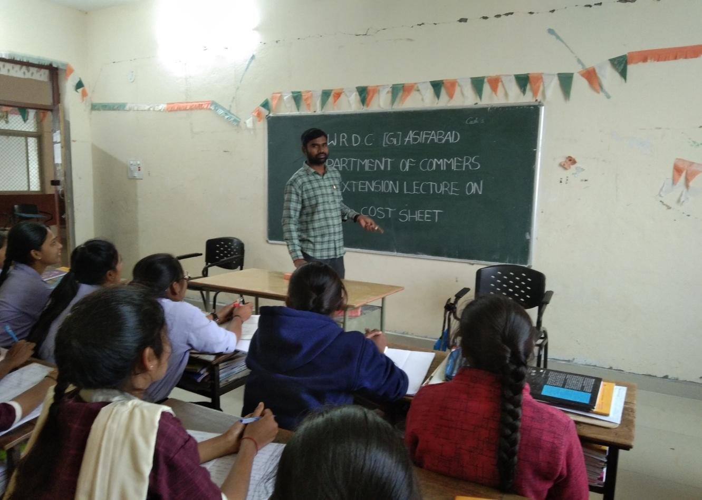

**V. RAVINDER REDDY, LECTURER IN COMMERCE, SRICHAITHANYA DEGREE COLLEGE, ASIFABAD**

**QUIZ COMPETITIONS ORGANISED BY THE DEPARTMENT**

|  |  |  |  |  |  |
| --- | --- | --- | --- | --- | --- |
| 2017-2018 | | | | | |
| S.NO | DATE | TOPIC | GROUP-A | GROUP-B | REMARKS WINNERS |
| 01 | 07-09-2018 | Introduction to joint  Stock Company | 1.A.srimathi  B.com | 1.K.Rajeshwari  B.com | GROUP-A |
|  | 2.CH.vijaya  B.com | 2.M.Sammakka  B.com |
|  | 3.D meera  B.com | 3.U.Kalpana  B.com |
|  | 4.D.mounika  B.com | 4.V.Lavanya  B.com |
|  | 5.K.swapna  B.com | 5.D.Gnaneshwari  B.com |

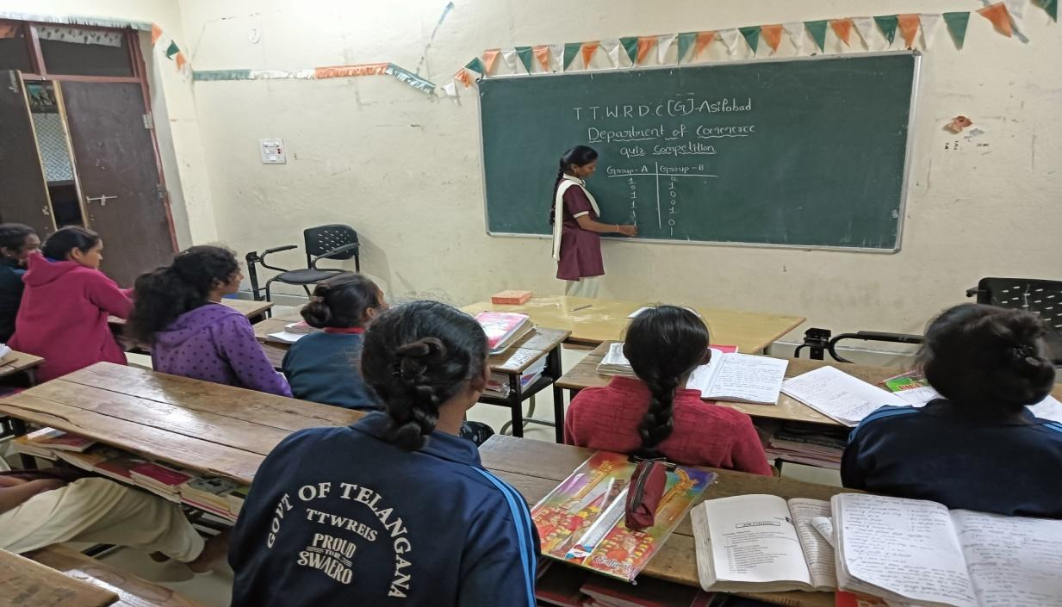

                                                                                      2018-2019

|  |  |  |  |  |  |
| --- | --- | --- | --- | --- | --- |
| 01 | 05-02-2019 | Types of Accounts | 1.A.Kavitha  B.com(CA) | 1.D.Sony  B.com(G) | GROUP-B |
|  | 2.A.Padma  B.com(CA) | 2.D.Srividya  B.com(G) |
|  | 3.B.Swathi   B.com(CA) | 3.J.Anusha  B.com(G) |
|  | 4.B.Renuka  B.com(CA) | 4.P.Divya B.com(G) |
|  | 5.D.komal  B.com(CA) | 5.P.Ramya B.com(G) |

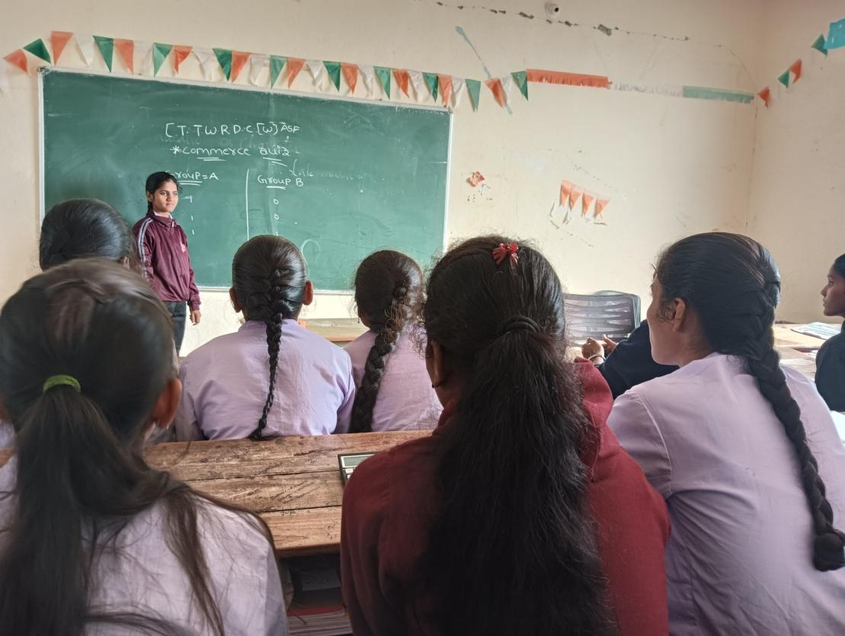

                                                                                 2020-2021

|  |  |  |  |  |  |
| --- | --- | --- | --- | --- | --- |
| 01 | 02-11-2020 | Types of subsidiary | 1.A.Sravani  B.com(CA) | 1.M.Yashoda  B.com(G) | GROUP-A |
|  | 2.K.Aruna  B.com(CA) | 2.M.Alekya  B.com(G) |
|  | 3.K.Kalyani  B.com(CA) | 3.V.Nikhitha  B.com(G) |
|  | 4.R.Manisha  B.com(CA) | 4.J.Teja  B.com(G) |
|  | | | 5.G.Nandini  B.com(CA) | 5.P.Priyanka  B.com(G) |  |

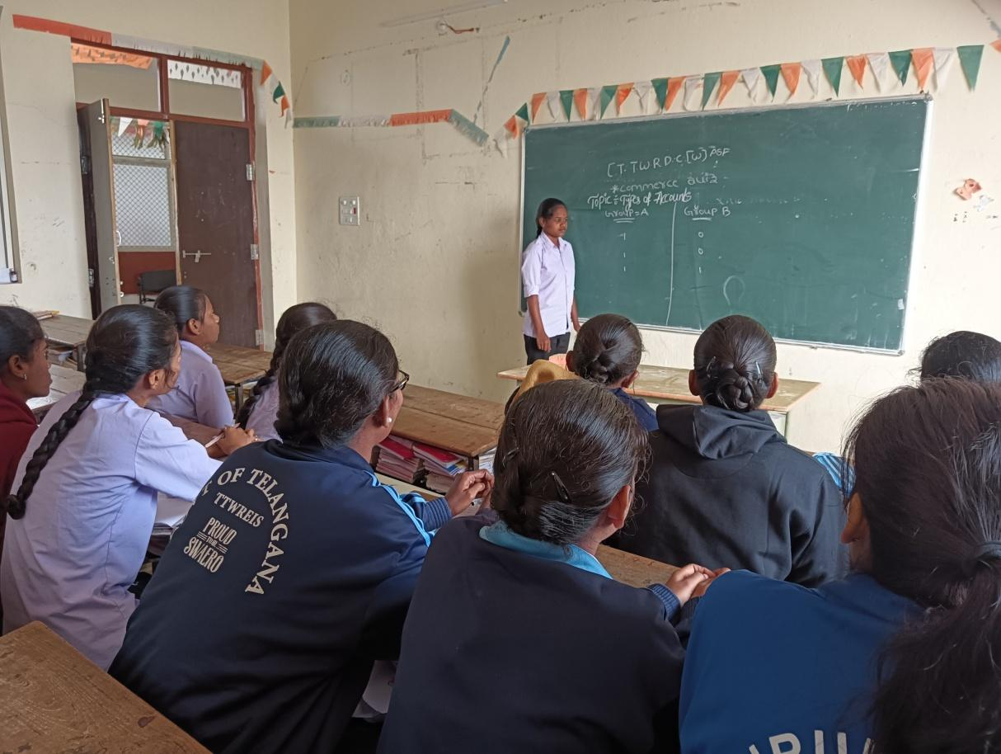

                                                                      2021-2022

|  |  |  |  |  |  |
| --- | --- | --- | --- | --- | --- |
|  | | | | | |
| 01 | 04-08-2021 | Marketing | 1.A.Shilpa  B.com(CA) | 1.K.Srilatha  B.com(G) | GROUP-B |
| 2021-2022 | 2.B.Nandini  B.com(CA) | 2.M.Premalatha  B.com(G) |
|  | 3.B.Jyothi  B.com(CA) | 3.S.Kavitha  B.com(G) |
|  | 4.B.Hyamavat  B.com(CA) | 4.V.Nikhitha  B.com(G) |
|  | 5.B.Swetha  B.com(CA) | 5.P.Padmasri  B.com(G) |

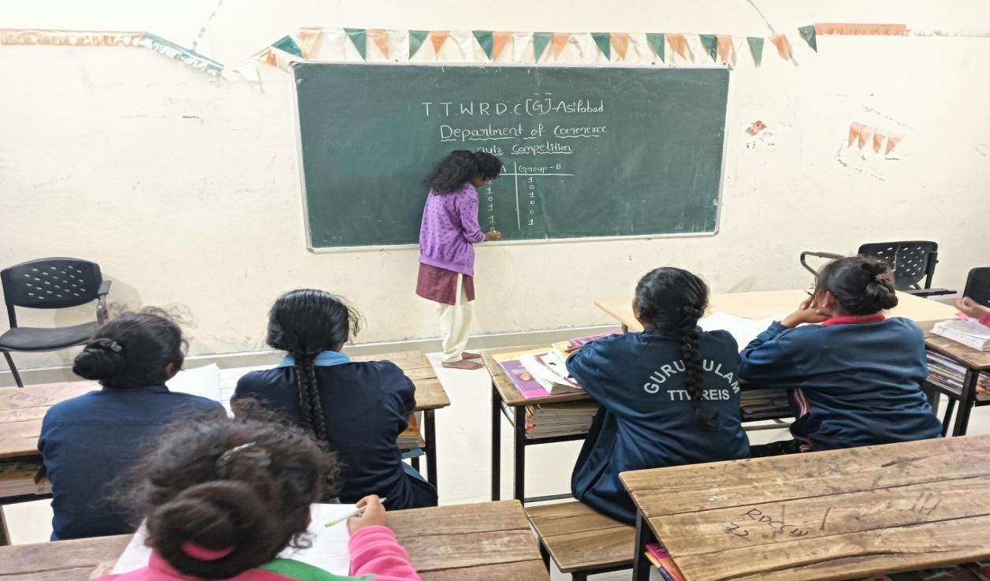

|  |  |  |  |  |  |
| --- | --- | --- | --- | --- | --- |
| 2022-2023 | | | | | |
| 01 | 10-03-2023 | General  knowledge | 1.P.Preethi  B.com(CA) | 1.A.sombai  B.com(G) | GROUP-A |
|  | 2.S.Priyanka  B.com(CA) | 2.M.Shravya  B.com(G) |
|  | 3.P.Manjula  B.com(CA) | 3.T.Suvarna  B.com(G) |
|  | 4.M.Pallavi  B.com(CA) | 4.T.Manasa  B.com(G) |
|  | 5.K.Nagalaxmi  B.com(CA) | 5.K.Samatha  B.com(G) |

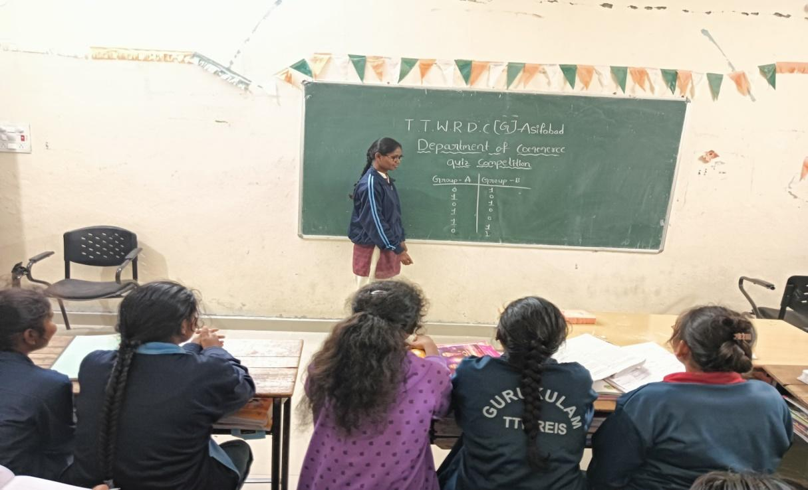

**DEPARMENT TIME TABLE**

# TIME TABLE : 1 Year

| **DAY** | **9.00 -10.00** | **10.00-11.00** |  | **11.10-12.10** | **12.10-1.10** |  | **2.00-3.00** | **3.00-5.00** |
| --- | --- | --- | --- | --- | --- | --- | --- | --- |
| **MON** | **BOM/ BLAW** | **FIT/PCS** | **BRECK** | **FA-1/FA-2** | **ENGLISH** | **LUNCH** | **NC** | **CLUB** |
| **TUE** | **BOM/ BLAW** | **FIT/PCS** | **FA-1/FA-2** | **ENGLISH** | **NC** | **CLUB** |
| **WED** | **BOM/ BLAW** | **FIT/PCS** | **FA-1/FA-2** | **ENGLISH** | **TELUGU** | **CLUB** |
| **THU** | **BOM/ BLAW** | **FIT/PCS** | **FA-1/FA-2** | **ENGLISH** | **TELUGU** | **CLUB** |
| **FRI** | **BOM/ BLAW** | **FIT/PCS** | **FA-1/FA-2** | **TELUGU** | **LIBRARY** | **CLUB** |
| **SAT** | **BOM/ BLAW** | **FIT/PCS** | **FA-1/FA-2** | **TELUGU** | **LIBRARY** | **CLUB** |

**TIME TABLE:II Year**

| **DAY** | **9.00 -10.00** | **10.00-11.00** |  | **11.10-12.10** | **12.10-1.10** |  | **2.00-3.00** | **3.00-5.00** |
| --- | --- | --- | --- | --- | --- | --- | --- | --- |
| **MON** | **RDBMS/WEB** | **ADA/IT** | **BRECK** | **TELUGU** | **BST-1/2** | **LUNCH** | **ENGLISH** | **CLUB** |
| **TUE** | **RDBMS/WEB** | **ADA/IT** | **TELUGU** | **BST-1/2** | **ENGLISH** | **CLUB** |
| **WED** | **RDBMS/WEB** | **ADA/IT** | **TELUGU** | **BST-1/2** | **ENGLISH** | **CLUB** |
| **THU** | **RDBMS/WEB** | **ADA/IT** | **NC-I** | **BST-1/2** | **NC-I** | **CLUB** |
| **FRI** | **RDBMS/WEB** | **ADA/IT** | **NC-II** | **BST-1/2** | **NC-II** | **CLUB** |
| **SAT** | **RDBMS/WEB** | **ADA/IT** | **LIBRARY** | **BST-1/2** | **LIBRARY** | **CLUB** |

**TIME TABLE:III Year**

| **DAY** | **9.00 -10.00** | **10.00-11.00** |  | **11.10-12.10** | **12.10-1.10** |  | **2.00-3.00** | **3.00-5.00** |
| --- | --- | --- | --- | --- | --- | --- | --- | --- |
| **MON** | **BE/RMPR** | **COST/CCMA** | **BRECK** | **ENGLISH** | **COMP/GST** | **LUNCH** | **E-COM/MLS** | **PG COACHING** |
| **TUE** | **BE/RMPR** | **COST/CCMA** | **ENGLISH** | **COMP/GST** | **E-COM/MLS** | **PG COACHING** |
| **WED** | **BE/RMPR** | **COST/CCMA** | **ENGLISH** | **COMP/GST** | **E-COM/MLS** | **PG COACHING** |
| **THU** | **BE/RMPR** | **COST/CCMA** | **TELUGU** | **COMP/GST** | **E-COM/MLS** | **PG COACHING** |
| **FRI** | **LIBRARY** | **COST/CCMA** | **TELUGU** | **COMP/GST** | **E-COM/MLS** | **PG COACHING** |
| **SAT** | **LIBRARY** | **COST/CCMA** | **TELUGU** | **COMP/GST** | **E-COM/MLS** | **PG COACHING** |